GLOBAL HOUSEHOLD ELECTRIFICATION
(TEAM GCP)
Adebesin Aramide Gloriah Munyao Ridwan Abdulrahman Oluwatomisin Arokodare
Abstract
OECD countries have made substantial strides in household electrification, benefiting from robust infrastructure and advanced technologies. This research paper delves into the distinctive energy landscape of OECD countries, exploring their accomplishments in achieving high rates of household electrification. Through a refined machine learning model, this paper further identifies regions with potential for improving electricity access, tailored to the unique context of OECD countries. Drawing upon a comprehensive review of existing literature and rigorous data analysis, the study investigates the factors underpinning the success of these economies in ensuring universal access to electricity. The insights derived from this study offer valuable lessons that can be extrapolated to guide energy access initiatives, not only within OECD member states but also in global contexts striving to enhance household electrification rates.
1. Introduction
Global Household electrification refers to the extent to which households around the world have access to electricity for their basic needs. It’s a measure of the percentage of households in each region or country that have access to electrical power. Electricity stands as a fundamental catalyst for eradicating poverty, fostering economic prosperity, and elevating living standards. As such, gauging the proportion of individuals with viable electricity access assumes paramount importance as a socio-economic metric. The concept of 'access to electricity' lacks a universally endorsed definition, although prevailing interpretations converge around the provision of reliable power, appropriate cooking amenities, and a designated minimum consumption threshold. The framework outlined by the International Energy Agency (IEA) extends beyond mere residential supply, encompassing specific electricity quotas for households, contingent on their urban or rural setting, with these benchmarks advancing over time. Presently, this minimal standard hovers at 250 kilowatt-hours (kWh) annually for rural families and 500 kWh for urban households. On a global scale, the proportion of the populace enjoying electricity access has demonstrated a consistent uptrend over the past several decades. In 1990, approximately 71% of the world's inhabitants possessed electricity access. This statistic surged to 87% by 2016, propelled by strides in both developed and developing nations. Notably, many OECD (Organization for Economic Co-operation and Development) countries have attained near-universal access to electricity, exemplifying the profound impact of robust infrastructure, technological innovation, and socio-economic policies. However, even within these prosperous nations, pockets of energy inequality persist, warranting ongoing efforts to ensure equitable distribution. Despite remarkable progress, the data also underscores that a segment comprising 13% of the global population remained devoid of electricity access as of 2016, primarily concentrated in less developed regions. This glaring disparity underscores the ongoing imperative to bridge this energy gap, aligning with sustainable development goals and universal prosperity ambitions. The shared responsibility of addressing this challenge rests upon governments, international organizations, and stakeholders, as they strive to weave electricity access into the fabric of a brighter and more inclusive future. The aim of this project is to tackle these pressing issues head-on by focusing on two key areas: refining the existing models and implementing advanced data handling techniques. The goal is to cultivate a globally comprehensive and dependable model that can serve as a foundation for making impactful decisions.

2. Literature Review
Household electrification plays a pivotal role in achieving sustainable development goals, with a focus on providing equitable energy access across the globe. While much research has concentrated on energy access in non-OECD countries, the literature often overlooks electrification dynamics in developed economies, particularly within OECD countries. This literature review aims to provide an overview of existing research, identify gaps, and explain how a new research project can fill those gaps by examining household electrification in OECD countries
The literature on household electrification emphasizes its significance as households worldwide account for a substantial portion of global energy consumption. OECD countries, despite being developed economies, contribute significantly to energy consumption and carbon emissions. For instance, OECD's carbon dioxide emissions in 2019 were significantly influenced by household energy use. Prior studies have primarily focused on energy access in non-OECD countries, often neglecting the electrification dynamics within developed nations.
Key gaps in the literature become apparent, which underscore the need for further research. Firstly, there is limited attention given to household electrification in developed countries, especially within the context of OECD nations. Existing datasets lack comprehensive integration of patterns and insights from OECD countries, hindering a holistic understanding of electrification dynamics. Moreover, potential disparities in energy access within developed economies and the potential for knowledge transfer of successful electrification strategies from OECD to non-OECD countries remain largely unexplored.
The proposed research project aims to address these identified gaps by shifting the focus from non-OECD to OECD countries, providing a fresh perspective on energy access. To achieve this, an enhanced household electrification model will be developed, integrating a more extensive and robust dataset that incorporates insights from OECD nations. The research intends to offer a comprehensive understanding of electrification dynamics within developed economies.
By considering household size, composition, and urban-rural disparities, the research project will contribute to understanding how demographic changes influence energy access. Michaël Aklin's work (2018) underscores the role of population density and urbanization in driving electrification rates. Additionally, the inclusion of multiple aspects, such as household type and composition, will enhance the model's ability to explain energy poverty trends, as emphasized by Ivanda's research (2022).
The research project also intends to offer valuable recommendations to accelerate electrification efforts globally. Through insights gained from analyzing mature dispatchable low-carbon energy sources and local resource utilization, the project will contribute to bridging the energy access gap in underserved regions. This aligns with the United Nations Sustainable Development Goal #7, which aims to ensure access to affordable, reliable, sustainable, and modern energy for all.
In conclusion, this literature review has outlined the existing research on household electrification, identified gaps in the literature, and explained how the proposed research project can fill those gaps. By shifting the focus to OECD countries and developing an enhanced electrification model, the project aims to offer insights that can accelerate energy access efforts globally, contributing to sustainable development and equitable energy distribution.

3. Methodology
Our methodology comprises a series of systematic steps designed to predict areas with low electricity supply. This process encompasses Exploratory Data Analysis (EDA), preprocessing, and the application of diverse machine learning algorithms. The objective is to accurately identify regions where electricity access is lacking. Below is a streamlined flow outlining the process of predicting areas with either low or high electricity supply based on the provided data:
3.1. Data Collection: To comprehensively grasp the dynamics of household electrification globally, multiple datasets were sourced from reputable organizations, including the International Energy Agency (IEA), Data World, and the World Health Organization (WHO).
International Energy Agency (IEA) The IEA dataset constitutes a pivotal source, encompassing valuable insights into electricity generation. Specifically, it spans the period from 2016 to 2023, offering a detailed breakdown of the electricity produced by each country. This dataset's focus on both the quantity and value of electricity generated serves as a foundational component for assessing energy access dynamics.
Data World: The dataset procured from Data World furnishes a broader perspective, covering a substantial time frame spanning from 1960 to 2017. This dataset is instrumental in establishing long-term trends in global electricity generation, facilitating historical analyses of energy production and its evolution over several decades.
WHO: The WHO dataset contributes a distinct dimension by providing information on the distribution of people in rural and urban areas.
3.2. Data Cleaning and Preparation: Reducing Cardinality: To enhance data quality and streamline analysis, certain adjustments were made to the datasets. Notably, data for the year 2023 was excluded from the IEA dataset due to its incomplete nature. Furthermore, a selective approach was taken to curate features, retaining only those relevant to OECD countries. This strategic refinement allows for a focused investigation into electrification dynamics within these developed economies.
Introducing New Features: In addition to refining the existing dataset, new features, namely “Electric urban” and “Electric rural,” were introduced. These new attributes encapsulate electrification levels specific to urban and rural contexts within the OECD countries. These features contribute depth to the analysis, enabling the project to uncover disparities in energy access across different population distributions.
Handling Missing Values: To address the challenge of missing data, the KNNImputer technique was harnessed, utilizing its capabilities to impute missing values based on the proximity of other data points. This approach ensures that the dataset retains its integrity while mitigating the impact of incomplete data. Recognizing the potential influence of zero values on predictive accuracy, a prudent step was taken to manage them. In instances where numerous values were registered as zeros, these entries were replaced with ‘NaN,’ designating them as missing values. The same KNNImputer methodology that was applied for handling missing values was extended to address the newly designated ‘NaN’ values stemming from the replaced zeros
Class Labels: Qcut method was used to convert "Value" continuous variable to a categorical variable with three classes; Low, Medium and High. .
3.3 Data Analysis: With data preprocessing complete, the subsequent phase entails a comprehensive analysis of the dataset to unveil any discernible correlations or patterns within the household electrification data. This exploration includes the utilization of statistical methodologies, including visualization techniques, to unearth insights.Our dataset pertaining to household electrification, now meticulously refined through feature engineering, comprises a total of 4308 entries across seven columns. These columns include:
- Location
- Year
- Value
- Electric_Urban
- Electric_Rural
- Rural Population Percentage
- Urban Population Percentage
Spanning from the year 1960 to 2022, this dataset encapsulates a temporal perspective that enables the analysis of evolving trends and patterns in household electrification over more than six decades. The inclusion of indicators such as urban and rural population percentages, alongside electrification metrics, facilitates a comprehensive examination of the interplay between urbanization, population dynamics, and electricity access.
The following observations were made:
- USA and Japan have recorded the highest number of Electric Values.
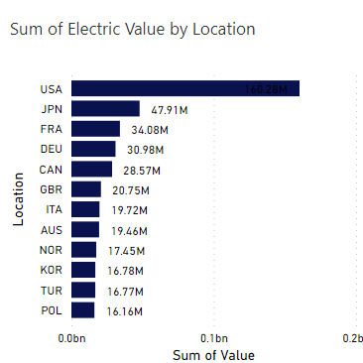Fig 1: Sum of electricity produced by location
- Belgium has the highest average urban population percentage followed closely by Iceland.
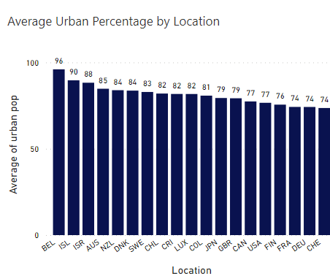
Fig 2: Average Urban Percentage by Location
- Slovenia has the highest average rural population percentage followed closely by Portugal
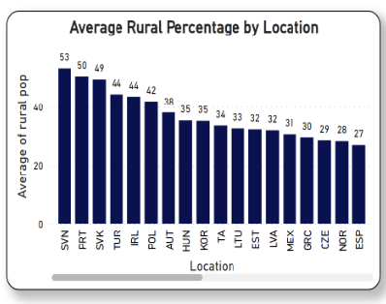
Fig 3: Average Rural Percentage by Location
- Very little correlation is observed among the features.
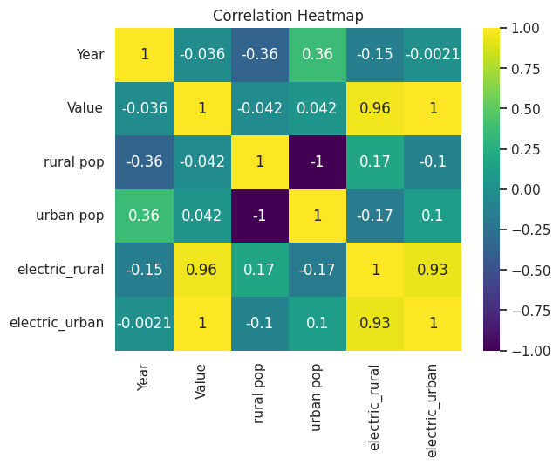
Fig 4: Correlation Heatmap showing the Relationship between Features

- The year 2014 has the highest total Electric values followed by the year 2010.
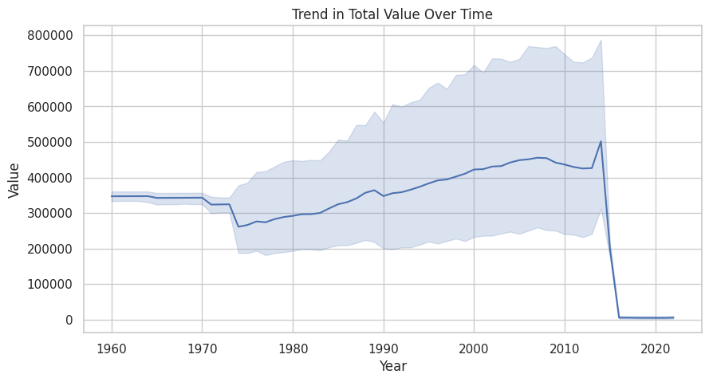

3.4 Model Training:
The training and testing sets were formed from an 80/20 split (respectively) of the dataset. To mitigate the impact of differing scales among features on the algorithm, the dataset underwent scaling through the application of the Standard Scaler. Also, categorical columns underwent transformation using Label Encoder. In addressing potential class imbalance, the Value column was balanced using the Synthetic Minority Over-sampling Technique (SMOTE). The Electric urban column was dropped to avoid multicollinearity.

Eleven (11) machine learning
algorithms were trained and evaluated on the resulting dataset. The algorithms include:
- DecisionTree Classifier
- Random Forest Classifier
- Gradient Boosting Classifier
- AdaBoost Classifier
- XGB Classifier
- LGBM Classifier
- CatBoost Classifier
- SVC
- GaussianNB
- Logistic Regression
- KNeighborsClassifier

After training and evaluating several models using the Cross Validation Score, the LGB (Light Gradient Boosting Machine) model emerged as the model that generalized better due to its consistent performance across various folds of the training data as shown below:
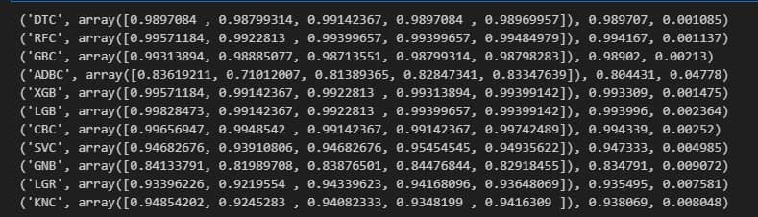
3.5 Model Evaluation:
Following the completion of model training, we proceeded to assess its performance, with the F1 score serving as our chosen metric due to the class imbalance within our dataset. To present a comprehensive evaluation, we employed both a classification report and a confusion matrix.The classification report allowed us to delve into the precision, recall, and F1 score for each class, offering insights into how well the model performed across different categories.
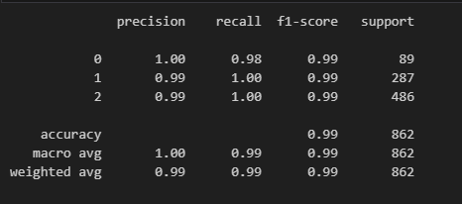

The confusion matrix visually depicted the alignment between predicted and actual values, aiding in understanding where the model excelled and where there might be room for improvement.
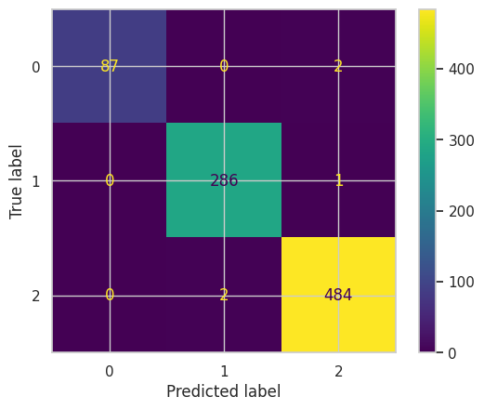
3.6 Model Deployment:
The deployment was done using the streamlit library in python and was hosted on streamlit cloud. Here is the link:
https://team-gcp-hamoye-hdsc-spring-23-capstone-project-nb6paq89gdxucg.streamlit.app/

4. Results
Since the LGB algorithm performed better, we then used cross validation and hyper parameter tuning to further improve the model giving us an accuracy score of 0.99.
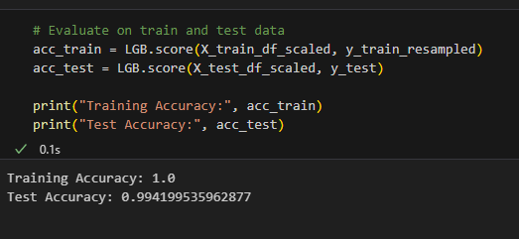

5. Conclusion
This research centered on the application of various machine learning algorithms to predict electricity values within OECD countries, thereby contributing to the enhancement of household electricity provisioning. Based on the gathered insights, it is reasonable to conclude that the Light Gradient Boosting Machine outperforms the other machine learning algorithms employed in this investigation for predicting household electrification.

6. References
- OECD, "Household behavior and residential energy use," in How Green is Household Behaviour?: Sustainable Choices in a Time of Interlocking Crises, OECD Publishing, 2023, p. 28
- S. H. J. U. Michaël Aklin, "A global analysis of progress in household electrification," Energy Policy, pp. 421-428, 2018.
- D. A. D. Z. Z. Oluleke O. Babayomi, " Affordable clean energy transition in developing countries: Pathways and technologies," iScience, p. 104178, 2022.
- M. S. a. K. Ivanda, "Electricity Access in non-OECD Countries: Do Household Size and Composition Matter?," Zagreb International Review of Economics & Business, pp. 83-99, 2022.

